**AIWINRAJ SREEJAYAN KURUPPATH ,(BCA)** 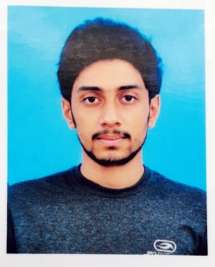

E-mail id : [aiwinraj1018@gmail.com](mailto:aiwinraj1018@gmail.com)

Contact : 7904895106

**CAREER OBJECTIVE**

I seek challenging opportunities where I can fully use my skills for the success of the organization**.**

**EDUCATIONAL BACKGROUND**

* **Bachelor of Computer Application** from **AJK College of Arts and Science** , **Coimbatore** affiliated to Bharathiar University with 65% (up to 4th semester).
* **Higher Secondary Certification** (Science Stream) from **ELGI Matric Higher Secondary School**, Coimbatorewith 69% in 2019.
* **Secondary School Certification** from **ELGI Matric Higher Secondary School**, **Coimbatore** with 88% in 2017.

**AWARDS AND ACHEVEMENTS**

* Certified A grade in NCC (National Cadet Corps) from ELGI matric higher secondary school, Coimbatore.
* Participated in Combined Annual Training camp conducted by 6th Tamil nadu Medical Company NCC.
* Honors in stage hosting.

**COMPUTER SKILLS**

* C , C++, Java Programming, Web designing, PhP.
* MS – Word , Excel , PowerPoint.
* Creative knowledge in **Adobe Premiere Pro** and **After Effects**.

**EXTRA CURRICULAR ACTIVITES**

* NCC Cadet
* Participated in District level football competition
* **Stage hosting**

**PERSONAL DETAILS**

Father’s Name : Sreejayan Kuruppath Raju

Mother’s Name : Priya Sreejayan

Date of Birth : 18 - 10- 2001

Permanent address : Kuruppath house, Kottekad P.O, Palakkad - 678732

Languages known : English, Malayalam, Tamil, Hindi and Kannada

Hobbies : Travelling, Playing football, Gaming and Exploring new ideas.

**REFERENCE**

**• Professor Kamalraj Anbazhagan**

Head of the Department, Department of Information Technology

AJK College of Arts and Science College, Coimbatore

Email ID: kamalraj@ajkcas.com

Mobile no: +91 9790556494

**DECLARATION**

I, hereby declare that the above information is authentic to the best of my knowledge.

Place : Coimbatore

Date : (AIWINRAJ )